ReactJS Hands-On Lab 3 - Output Report

Objective
Create a React application "ScoreCalculatorApp" with a functional component "CalculateScore" that displays student details, total marks, goal, and calculates the average score.

Environment Setup & Project Creation
Created a new React project using create-react-app and verified project creation:
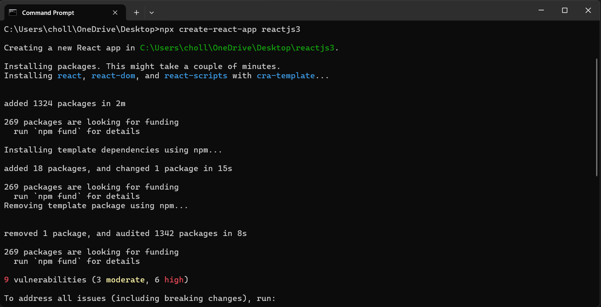
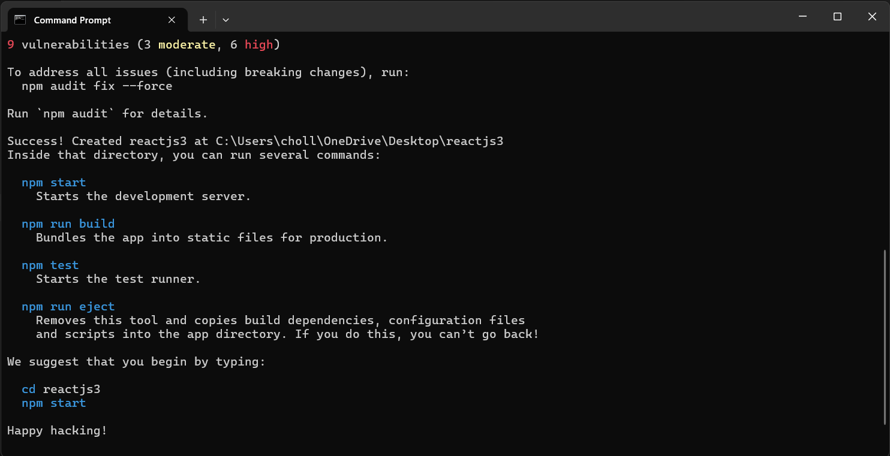

Project in VS Code
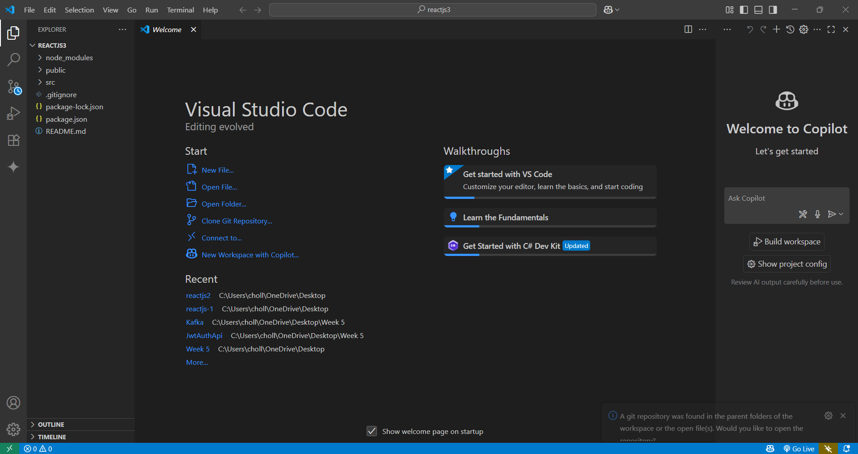

Component Creation
Created the functional component CalculateScore.js under src/Components folder:
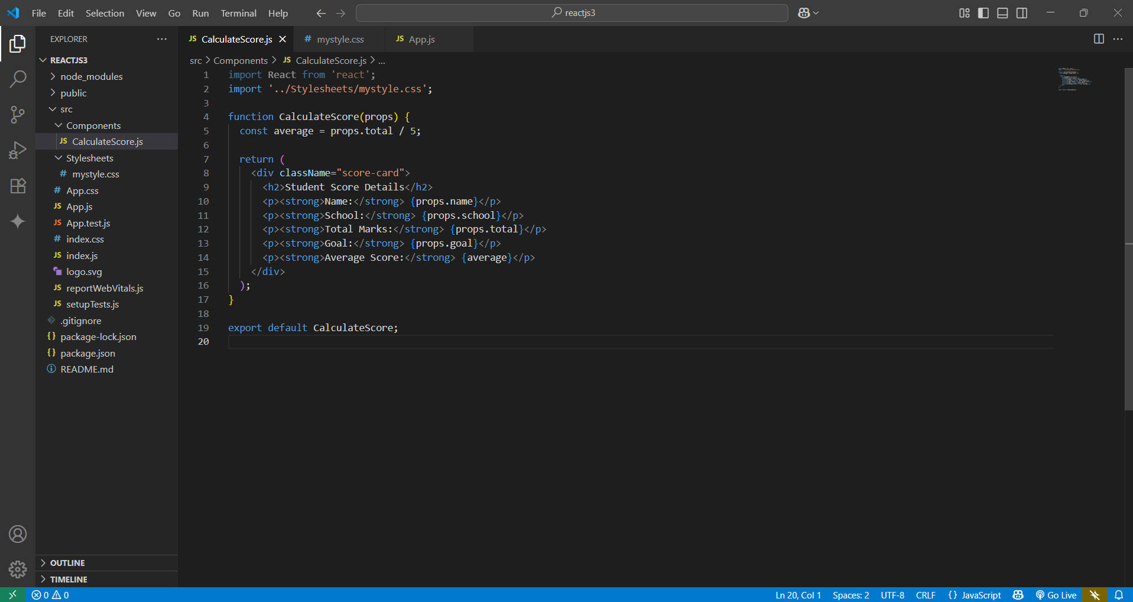

Styling
Created mystyle.css under src/Components/Stylesheets folder for styling the component:
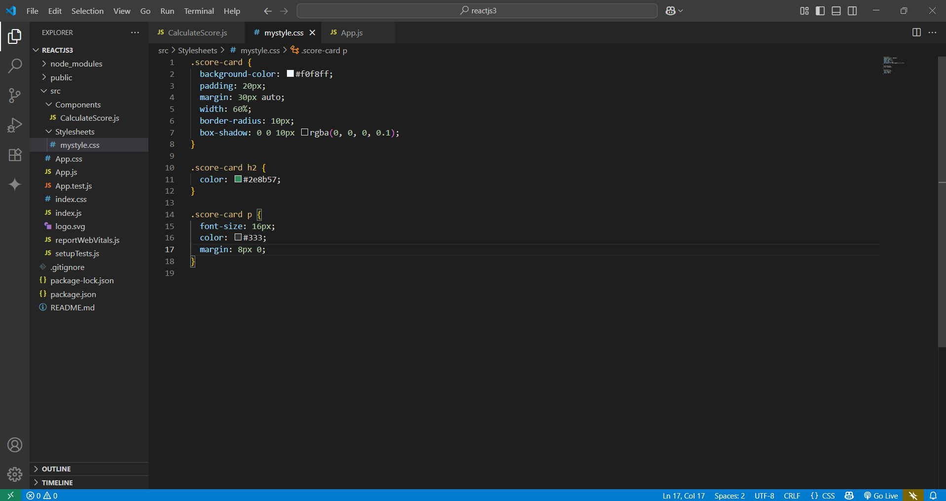

Edited App.js
Edited App.js to display student details using CalculateScore component:
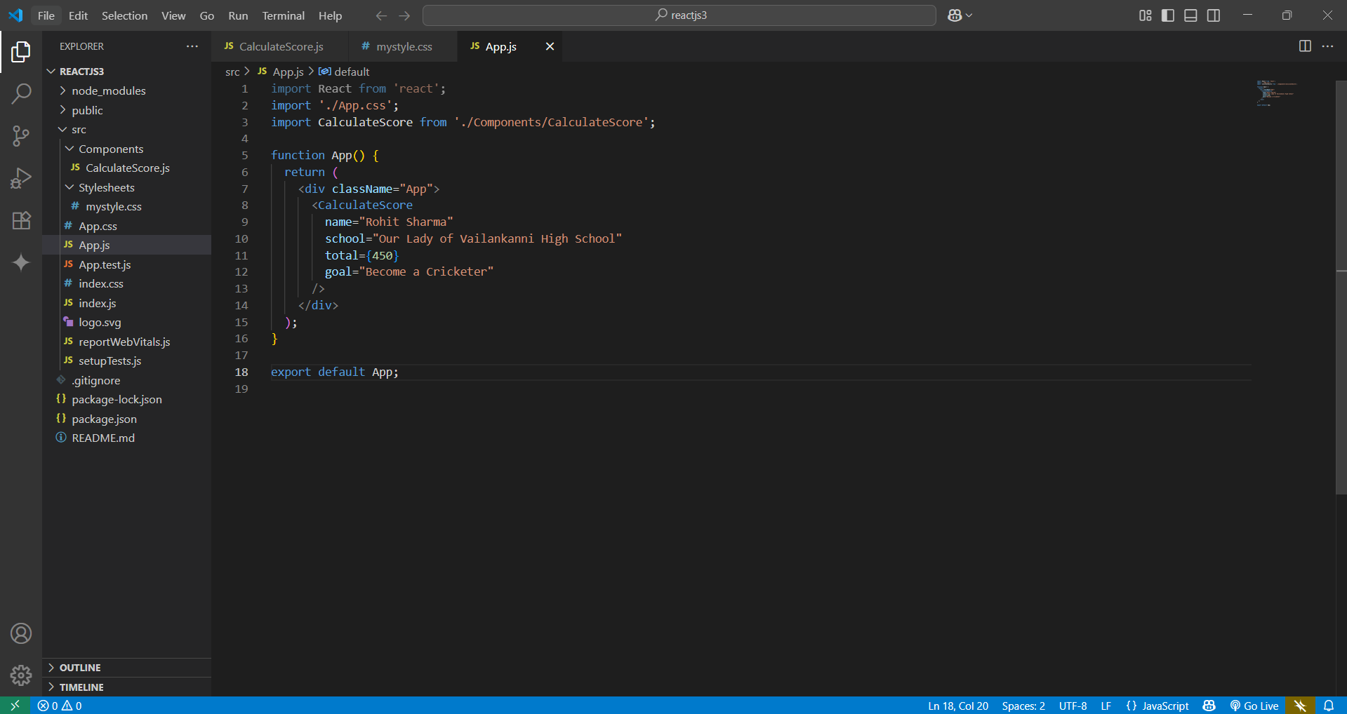

Webpack Compilation
Started the development server and verified successful compilation:
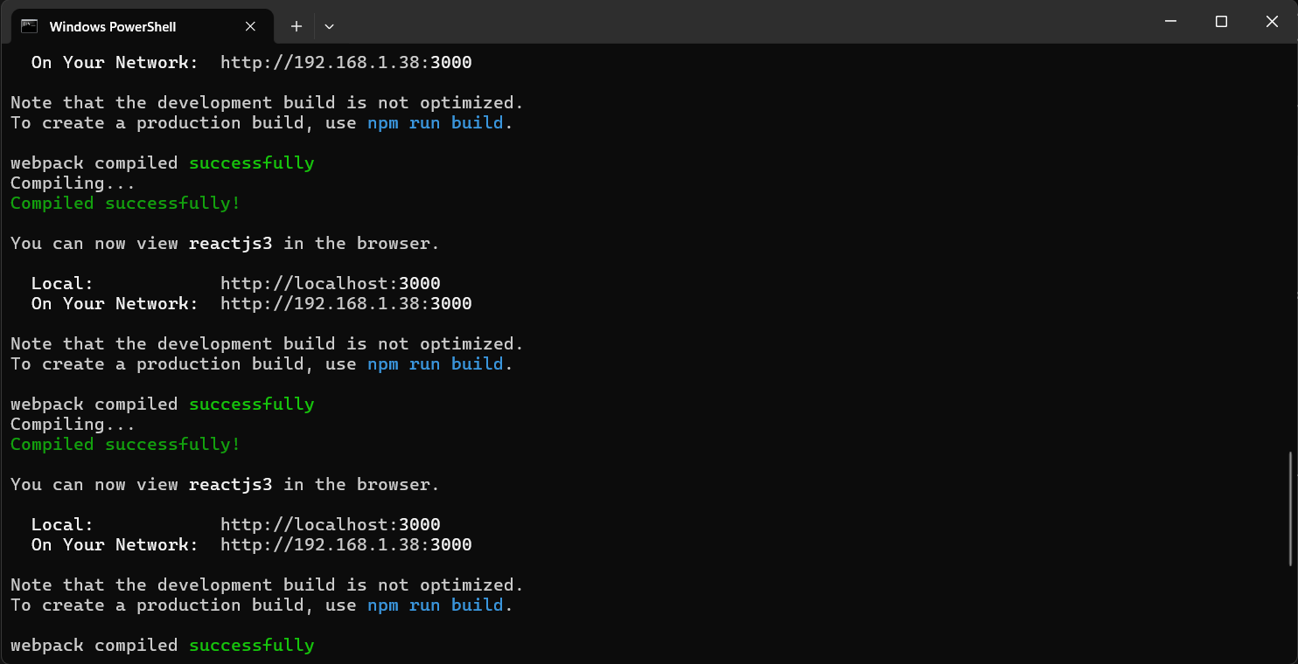

Browser Output
Verified that the React app displays student details and calculated average score in the browser:
